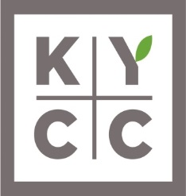

Employee Referral Form

Koreatown Youth & Community Center (KYCC) takes great pride in its recruitment and selection process. Our past history indicates that one of the best sources for candidates, who are likely to meet our rigorous standards, are often located through our existing employees. Therefore, as part of our recruitment and selection process, we have implemented a new employee referral program. Employees of KYCC are immediately eligible to refer candidates, who if hired, will result in your receipt of a referral award in the amount of $100.00 (less taxes).
The referral award program guidelines are as follows:

1. The referred candidate must include the KYCC staff that referred them on the KYCC application.
2. No referral awards are paid for referral of relatives of employees.
3. Temporary employees, interns, and volunteers are not eligible for the referral award. You must be a current Regular Full-Time or Regular Part-Time employee to be eligible.
4. Human Resources and Directors/Managers/Supervisors to whom a candidate will report are excluded from receiving referral awards. If a Director/Manager/Supervisor referrals an applicant to another department, that manager would be eligible for the referral.
5. Former KYCC employees (Rehired employees) are not eligible to be a new employee referral.
6. In the event that the same candidate is referred by more than one employee, the date of the earliest referral will apply.
7. Once a referral is hired and completes 6 months of service, the employee that referred the new hire will receive an additional $200.00 (less taxes). Temporary positions are not eligible.

If you have a candidate for referral, please complete this form and forward to Human Resources.

Employee ___________________________________ Date_______________________
Candidate Name _________________________________
Cell _________________________ Email _______________________________________
Position for which candidate is being referred? ___________________________________
Revised 3/2018

